**Field Class Volunteer**

**Manual**

**Welcome................................................................2**

**School Programs Staff............................................2**

**3 Field Class Volunteer Roles...............................3-4**

**Field Trip Logistics ..............................................5-7**

* **Where to meet.........................................5**
* **Times to meet..........................................6**
* **Inclement Weather ..................................6**
* **Safety Measures.......................................7**
* **Training...................................................7**
* **Volgistics.................................................7**

**Field Class Program in a Nutshell …....................8-9**

**Our Field Class Goals ….....................................9-10**

**Focused Learning Day …...................................10-11**

**Thank you! ….......................................................11**



**Welcome**

Field Class Volunteers enhance the outdoor and educational experience for K-6th grade public school students. Field Class Volunteers have many opportunities, including:

* Helping Red Butte Garden education staff provide an outdoor science-based field trip experience for students.
* Enhancing student connections to nature and the Garden.
* Increasing student access to the outdoors.
* Practicing science skills with students and making science feel relevant and accessible.

**School Programs Staff**

**School Programs Manager:** (All School Programs, Grow Lab)

Nick Hoffmann [Nick.Hoffmann@redbutte.utah.edu](mailto:Nick.Hoffmann@redbutte.utah.edu)

**School Programs Garden Experience Coordinator:** (Field Classes)

Becca Speechley [Becca.Speechley@redbutte.utah.edu](mailto:Becca.Speechley@redbutte.utah.edu)

**School Programs Teacher Resource Coordinator:** (Botany Boxes, Botany Bins)

Heather Paulsen [Heather.Paulsen@redbutte.utah.edu](mailto:Heather.Paulsen@redbutte.utah.edu)

**School Programs Outreach Coordinator:** (Grow Labs)

Mary Hollyman [Mary](mailto:Mary).Hollyman@RedButte.utah.edu

**3 Field Class Volunteer Roles**

The specific responsibilities, training materials, and mock demonstrations of volunteer roles are provided during fall or spring Field Class Volunteer Training.

**Plant Pal**  (Activity Assistant)

This volunteer acts alongside Garden Educators and **assists** in student activities as needed. This volunteer also helps with the general flow of the groups surrounding an activity.

**What type of volunteer this would take**: Someone that enjoys working alongside garden staff educators. Someone that likes to generally work with students and interact with them, but not necessarily be the main facilitator.

**Needs for role:**

* + Understand volunteer responsibilities from specific Plant Pal Maual.
  + Utilize provided resources offered at the training to understand your field trip topics. (Volunteer Field Trip Reference Sheet)
  + Have access to ongoing Garden Tours, Safety/Wildlife training opportunities and any educational interpretative opportunities.

**Garden Sage** (Stationary Educational Docent)

This volunteer is assigned to a general area within the garden where they will be enhancing the educational experience for students.

**What type of volunteer this would take**: Someone that likes to interact with groups of students and share educational information. Someone that is okay standing or being on their feet for up to 2-hour segments by themselves. Someone that feels comfortable taking initiative and talking to student groups that visit.

**Needs for role:**

* Understand volunteer responsibilities from specific Garden Sage Manual.
* Observe a mock demonstration of the role at a Field Class Volunteer Training.
* Utilize provided resources offered at the training to know the garden areas and field trip topics. (Garden Interpretation Sheet and Volunteer Field Trip Reference Sheet)
* Have access to ongoing Garden Tours, Safety/Wildlife training opportunities and any educational interpretative opportunities.

**Roving Rosebud**  (Roaming Educational Docent)

This volunteer is an educational roving volunteer that typically walks the main loop of the Garden to enhance the educational experience for students. This volunteer is available to help groups with their navigational needs.

**What type of volunteer this would take:**Someone that enjoys walking and engaging with groups during most of their volunteer time. Someone that can adjust to needs of the day and be willing to improvise if a group requires more assistance (navigating the Garden). Someone who knows their way around the garden and feels comfortable navigating and sharing information about the Garden with others.

**Needs for role:**

* Understand volunteer responsibilities from specific Roving Rosebud Manual.
* Observe a mock demonstration of the role at a Field Class Volunteer Training.
* Walk the Garden with a Garden Educator for ideas and inspiration.
* Utilize provided resources to know the garden areas and field trip topics. (Garden Interpretation Sheet and Volunteer Field Trip Reference Sheet)
* Access to ongoing Garden Tours, Safety/Wildlife training opportunities and any educational interpretative opportunities.

*If you’d like to be involved with any of the above jobs, join in a spring or fall field class training from a Garden Educator (School Programs staff), then sign up in Volgistics for shifts.*

**Field Trip Logistics**

**Where to meet for a shift:**

After you clock in at the Visitor’s Center, please meet Garden Educators at the designated spot that is listed in Volgistics.

If your signup listed “Orangerie Gate”, we meet at the north end of the Red Butte Garden Parking lot (next to the dumpsters). This spot designates a Red Butte Garden only field trip.

If your sign up listed “NHMU Gate”, we meet in front of The Natural History Museum of Utah at 9:30am, and we meet at the side NHMU/RBG gate at 11:30am. These spots designate that students are going to Red Butte Garden and The Natural History Museum of Utah for their field trip.

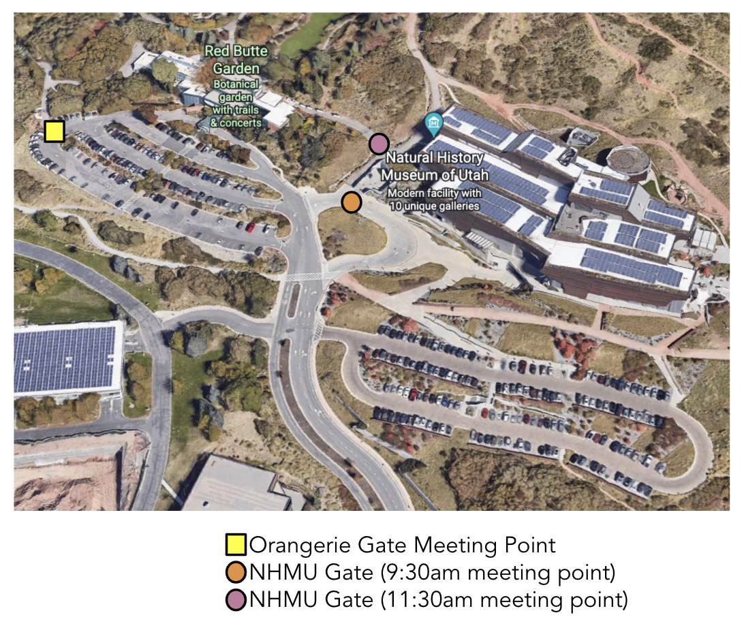

**Time to meet:**

Each Volgistic shift states the time for the full student program. If possible, please arrive early to sign into your shift in the Visitor’s Center and then meet Garden Education Staff prior to the Field Trip at the designated meeting spot. If you’re running late, you can have the Front Desk radio School Programs. The general field trip times are posted below.

Time changes can happen. Sometimes school buses cannot arrive for our general field trip times and sometimes schools must leave early. **All times posted in Volgistics are the updated accurate times for the volunteer shift and field trips. The times listed are generalized.**

|  |  |  |
| --- | --- | --- |
|  | **Red Butte Garden only field trips**  **(Meet at Orangerie Gate)** | **Red Butte Garden/ Natural History Museum (Meet at NHMU Gate)** |
| Morning | 9:30-11:00am (K-2nd)  9:30-11:30am (3rd-6th)  * | 9:30-11:15am  * |
| Staff/Volunteer break  Staff sanitize and switch materials  Staff and Volunteers Greet Next Group | | |
| Afternoon | 12:00pm –1:30pm (K-2nd)  12:00pm-2:00pm (3rd-6th)  * | 11:30 am-1:00pm (K-2nd)  11:30am-1:30pm (3rd-6th)  * |
| * Staff and volunteers will be testing out ending activities slightly early (20 minutes early every trip). This will encourage groups to transition, as well as provide more adequate time for material sanitization, materials refreshing, and breaks.  * All trips are as seen above unless specified in Volgistics. If you are signed up in Volgistics for a trip you will be notified of any time change alterations. | | |

**Inclement Weather**

If deemed safe by the school and Garden Education staff, we will run the planned field trip during inclement weather. Depending on the weather conditions, we will facilitate our field trip activities either outside or indoors. Volunteer roles are subject to change due to the shifting programs due to weather, we appreciate your flexibility and patience on these days. Roving Rosebuds or Garden Sages could be stationed in an indoor location or, we may need help with things like hanging and drying ponchos. In cases of extreme conditions, we will cancel the field trip and we will notify all volunteers signed up within Volgistics immediately. You may opt for test message alerts for this kind of notification.

**Safety Measures**

**Lost child-** please notify Red Butte Staff with a radio if a group has lost child or lost caregiver. Do not share the students name, only the student’s description.

**Emergency and snake bites-** call 911 and contact Visitors Center or staff with nearest radio. Radios are used by staff to communicate in an emergency.

**Severe Air Quality Index-** we will cancel outdoor programming for Field Classes. Please don’t hesitate to cancel a shift if needed.

**Training Opportunities**

Training is offered in spring and fall with monthly opportunities through the volunteer season for educational classes led by our horticulture crew leads to ensure you have the knowledge needed to be successful in your position.

Potential Trainings Include:

* + Horticulture Staff Tours (when available)
  + Wildlife Safety Training
  + Heat Safety Training
  + Interpretation Training and Materials
  + Specific training for Field Class Volunteer Roles

**Volgistics**

This program is used for all scheduling and volunteer communication. Please update your schedule in Volgistics as needed and sign in and out at the Visitor Center for each shift. If you have any issues with Volgistics or would like a tutorial in how to use it, please contact Red Butte Garden Volunteer Coordinator: Julie Duckett ([Julie.Duckett@RedButte.utah.edu](mailto:Julie.duckett@redbutte.utah.edu))

Volunteers that are signed up for field trips in Volgistics can be notified of any time change alterations or field trip updates.

**Field Class Program in a Nutshell**

Field classes are outdoor science-based field trips for Kindergarten-6th grade students in Utah. We receive funding each year from the Utah State Legislature as a part of the iSEE (Informal Science Education Enhancement) program. This funding allows us to run our School Programs department and offer programs free of charge to publicly funded schools in Utah.

**Components:**

**1)K-6th teachers choose the field trip option for their students.**

All options have different activities, science standards, and overall focuses. We call these field trip options “Investigations”.

Kindergarten-2nd Grade have 3 choices of Investigations**:**

**Sensory Observations:** Use my senses to observe living things.

**Habitats:** How do living things survive in different habitats?

**Flowers and Seeds:** How do plants survive and reproduce?

3rd-6th Grade have 4 choices of Investigations:

**Phenology:** What life cycle changes are happening right now?

**Ethnobotany:** How do plants and humans help each other?

**Matter Movement:** How are different organisms connected?

**Water Conservation:** How do living things survive in dry, desert climates?

**2) Once a school is scheduled with their Investigation, the Field Class (field trip) experience consists of 3 parts: Pre-Garden Activity, Garden Field Trip, Post-Garden Activity**

1. **Pre-Garden Activity called Virtual Garden.**

This is a 360-degree interactive tour of the Garden that introduces students to their Investigation. This is done in the classroom before students visit the Garden.

Please email Christine if you’d like to check out the tours to know what students are watching prior to visiting the Garden.

**B) Garden Field Trip:**

* Students visit the Garden and are turned into scientists to study their investigation. The Garden is the student’s space for observing, exploring, gathering information, and communicating findings with each other.
* Students receive Field Journals specific to their investigation and pencils when they arrive (both are theirs to keep).
* Chaperones/Teachers receive backpacks specific to their Investigation with items like magnifiers, scavenger hunts, maps, Garden information, etc.
* Field trip participants (students, teachers, and chaperones) explore the Garden, focusing on their Investigation. Garden Educators and Volunteers are stationed in different Garden areas (depending on each field trip).
* Garden Educators facilitate 2 activities for each specific field trip and will be potentially testing out 3rd activity this season (dependent on staffing). Field Class Volunteers assist in these activities (Plant Pals) or, they are located around the Garden and enhance the educational experience for the students (Garden Sage, Roving Rosebud).
* We host Red Butte Garden only field trips and we host partnership field trips with the Natural History Museum of Utah where students get to visit both the Garden and Museum.

**C)Post-Garden Activity:**

This activity is conducted by the teacher after the field trip. The activity connects the investigation back to the student’s school and their own neighborhoods. These activities are in development with the help of University of Utah Graduate student and RBG Intern, Sam Nelson. These activities will connect science with literacy and encourage the continuation of using the outdoors as a classroom.

**Our Goals for Field Classes at Red Butte Garden**

**Students practice science skills**

In Field Classes, we strive for our programs to be driven by curiosity. We are leaning into students “doing” science while they are visiting and having the garden feel like an outdoor interactive learning space. While at the Garden, students will be gathering information and beginning to communicate their findings. As staff and volunteers, we are working to validate student observations, incorporate science skills and terminology, open opportunities to demonstrate that failure is as important as success (especially in science!), and remind students that they are studying and practicing science like a real scientist would. Utah Science and Engineering Standards state, “*the goal of [the standards] is to provide students with the education they deserve, honoring their ability, their potential, and their right to utilize scientific thought and skills for themselves, and the world that they will build.”* (Introduction, pg. 15)

**Students are connected and empowered to explore their world outside of the Garden**

We welcome all students in the Garden. Whether this is a once in a lifetime or everyday experience, Field Class students live our mission by exploring nature and connecting to plants and science education. As staff and volunteers, we strive to make students feel like the Garden is a place they belong, which is a big part of creating that connection.  Any chance to relate the experience to something students can continue to explore in nature in their schoolyard or in their own neighborhoods is valuable. Post-Garden Activities encourage the continued exploration in their own environments.

**Students feel the experience in relevant and meaningful to them**

We hope to utilize continual evaluations, feedback, and partnerships to shape the program to be meaningful to all students. We will be running Focused Learning Days in Spring to better reach neurodiverse students and understand how we can better serve this community each day. We want to offer students learning opportunities, as well as comfortable and safe spaces for them to roam, socially connect, and reflect in the outdoors. We will be providing bounce-back passes for all students visiting. This is one way they can return to the Garden and share their experience with their friends and families.

**Field Class Focused Learning Day:**

This is a field trip day geared towards being accessible to neurodiverse students and students with special needs. On Focused Learning Days, Red Butte Garden and the Natural History Museum of Utah have special accommodations and volunteer-led activities specific to the group reserved. Feedback from this day will help RBG and NHMU improve programming for all students.

Volunteers are needed during Focused Learning Day in different capacities!

What is offered during Focused Learning Day:

* A dedicated quite space created for students who may need a break.
* Exhibition sounds at NHMU are turned down.
* Red Butte Garden works with their gardening teams to make sure loud equipment is not used during the field trips.
* Resources such as noise cancelling headphones or 3D models at NHMU are provided for those that need them.
* Exploration at both RBG and NHMU are free flowing between locations so students can explore either location at their leisure or take breaks from the heat/cold outside.
* Lunch periods at NHMU are extended. This means students have access to the NHMU lunchroom at any time, rather than a set scheduled time.
* Higher adult to student ratios are permitted for free.
* Both Red Butte Garden and NHMU provide drop-in activities with extra staff and volunteers. Past NHMU activities have included Rock and Mineral explorations and a STEM challenge.  Past RBG activities have included optional tasting of plants, scavenger hunts, and hands-on activities with plant parts.

**Thank you!**

From Red Butte Garden School Programs Staff and the thousands of students we reach each school year!

A few of the many quotes from students and teachers:

“I want to be a scientist. Actually, I just want to work here. How old do I have to be to work here?”- 4th Grade Orchard Springs, 2021

“This place really helps me to unload my stresses.” -4th Grade Orchard Springs, 2021

“This is the best day of my life”- Hayden Peak, 3rd Grade, 2021

“Our students were very engaged and loved the hands-on experiences. They were so excited about everything they saw and did. The experiences fit well with our SEED standards and helped to make science come to life. This field trip is always so fun for the kids. They don't even realize they learning and still doing school. Thank you!”

-Emily Jensen, Stewart Elementary, 2021 (NHMU/RBG)